Gene Editing with CRISPR-Cas – A Potential Cure for Severe Sickle Cell Anemia

Victoria Gray had severe sickle cell anemia with repeated painful crises when sickled red blood cells blocked her circulation. She said, "The pain is excruciating. It's like being in a car accident and having lightning in your chest. It's a pain that makes a grown woman like me scream."  Since many sickle cell patients don't survive past their 40s, Victoria Gray worried that she wouldn’t live to see her children grow up. "It's horrible ... knowing that I could have a stroke or a heart attack ... at any time," she said. | 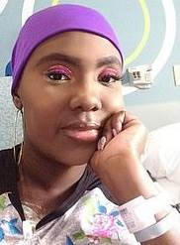
Figure A shows the effects of the normal hemoglobin allele. Figure B shows the effects of the homozygous sickle cell hemoglobin allele.

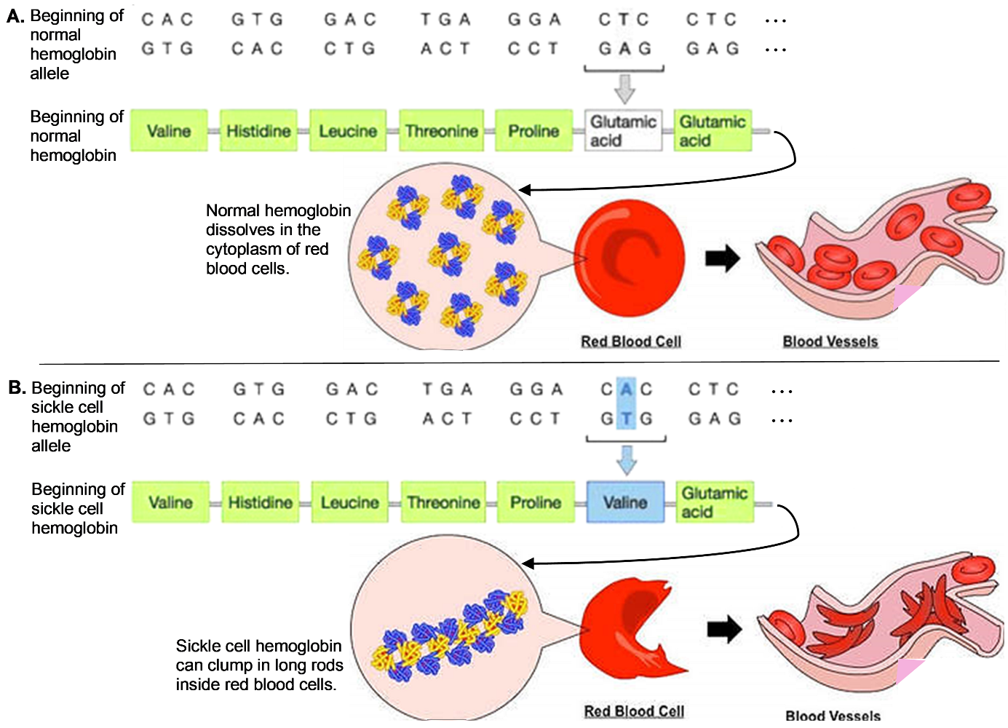

1. Put the letter of each description next to the relevant part of figure B.
A. A change in a pair of nucleotides in the DNA causes a change in one amino acid in the hemoglobin protein.
B. As a result, the hemoglobin molecules can clump in long rods.
C. These rods can result in banana-shaped or sickled red blood cells.
D. Sickled red blood cells can block blood flow, which causes pain and damage to body organs.

How DNA Gives the Instructions for Making a Protein

In this section, we will review how proteins are made by transcription and translation. This review will help you to understand the CRISPR-Cas gene editing treatment that cured Victoria Gray’s sickle cell anemia.

2a. Label the DNA, mRNA, protein and ribosome in this figure.

2b. Label the arrow that represents transcription.

2c. What does the other arrow represent?

2d. Circle the part of the figure that represents translation.

This figure summarizes how transcription makes mRNA.

Each DNA nucleotide in the gene is matched with a complementary RNA nucleotide which has a matching shape and charge distribution. Each RNA nucleotide is joined to the previous RNA nucleotide to make the growing mRNA molecule.

3a. Fill in each blank in this figure with DNA or mRNA.

3b. The base-pairing rules summarize which pairs of nucleotides are complementary.
G always pairs with ___. T in DNA pairs with ___ in mRNA. A in DNA pairs with ___ in mRNA.

4a. There are 20 types of amino acids in proteins, but only 4 types of nucleotides in mRNA. How does mRNA provide a unique code for each type of amino acid? | 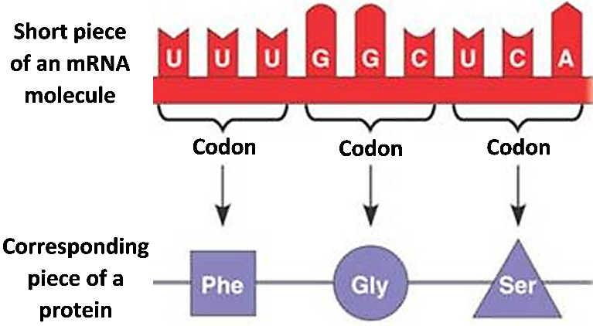

4b. How many nucleotides does an mRNA molecule have to have in order to give the instructions for making a protein with 100 amino acids?
100 ___ 200 ___ 300 ___ 600 ___

What is CRISPR-Cas?

Because none of the usual treatments controlled Victoria Gray’s severe sickle cell anemia, she volunteered to be the first person to receive a new type of treatment. To develop this treatment, scientists adapted the CRISPR-Cas molecules that bacteria use to defend themselves against viral infections. A viral infection can kill a bacterium that lacks effective defenses.
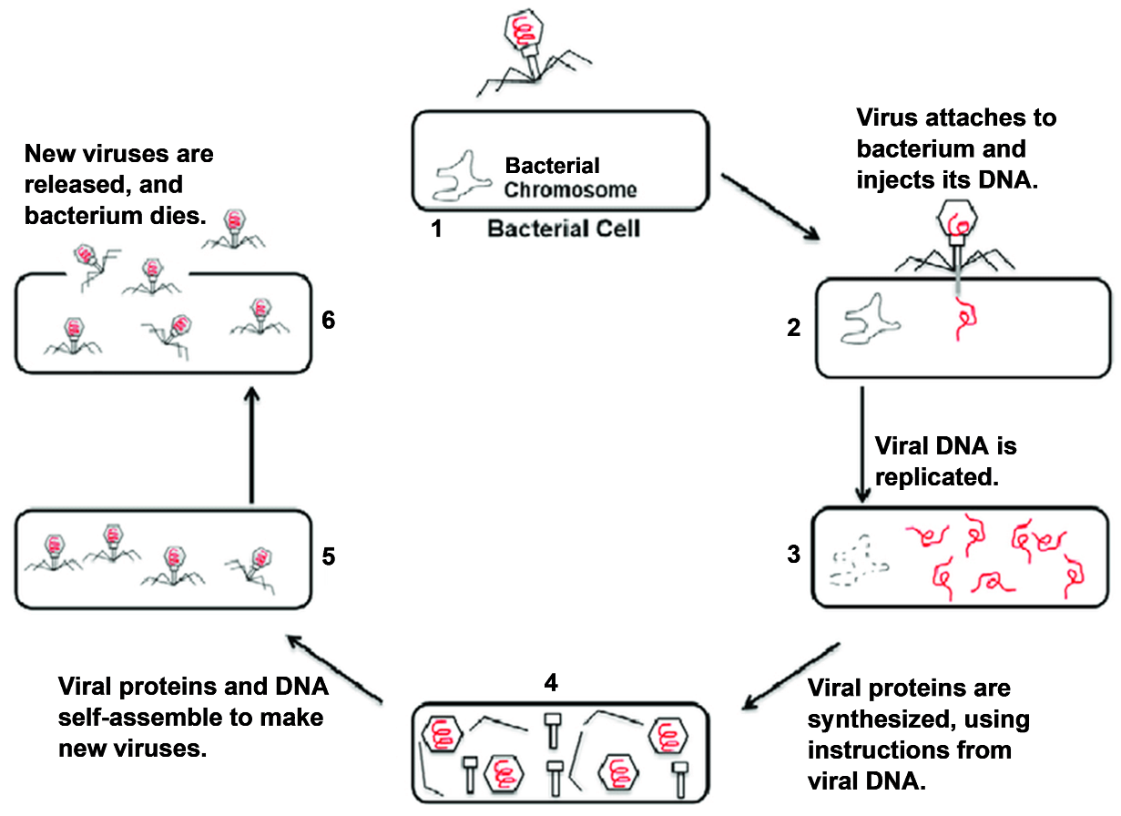

5a. Circle the drawing that shows the virus injecting its DNA into the bacterium.

5b. How would the bacterium benefit from being able to destroy or inactivate the viral DNA?

To learn how bacteria defend themselves against viral infection, watch “What is CRISPR-Cas?” (https://www.youtube.com/watch?v=52jOEPzhpzc).

6a. How does a Cas enzyme help to defend a bacterium against viral infection?

6b. Suppose a specific type of virus has previously infected a virus or one of its ancestors. How does an RNA guide help a bacterium fight a repeat infection by this specific type of virus?

To learn more about how CRISPR-Cas9 can be used to treat genetic diseases like sickle cell anemia, watch “CRISPR Explained” (https://www.youtube.com/watch?v=UKbrwPL3wXE).

7. Describe how guide RNA and the Cas9 enzyme can be used to cut DNA in a specific location to inactivate a specific gene. | 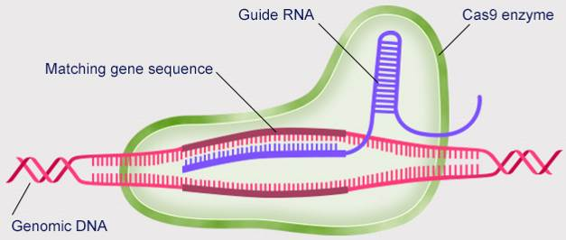

Why did doctors want to increase fetal hemoglobin in Victoria Gray’s red blood cells?

To find a suitable gene to modify with CRISPR-Cas, doctors began with research results concerning fetal hemoglobin. This special type of hemoglobin is produced by the fetus before birth.

A. In 1948, a doctor reported that, when children with sickle cell anemia were newborns, very few of their red blood cells were sickled. The doctor suggested that newborns’ red blood cells were protected by their higher levels of fetal hemoglobin.

B. Research during 1972-1994 showed that some sickle cell patients had genes that resulted in continued production of fetal hemoglobin after birth. These sickle cell patients had milder sickle cell disease and lived longer.

C. A 1995 study found “that hydroxyurea, which reactivates fetal hemoglobin production, reduces the number and severity of sickle-cell attacks in adults.… But hydroxyurea can cause toxicity and helps only about half of all patients.”

Source: “Sickle cell gene therapy to boost fetal hemoglobin: A 70-year timeline of discovery” (https://answers.childrenshospital.org/sickle-cell-gene-therapy-bcl11a-timeline/)

8a. In the table below, summarize each of the above research results.

Circumstance in which  Fetal Hemoglobin Is Higher | How was the severity of sickle cell disease measured? | How did severity differ when fetal hemoglobin was higher?
A.
B.

C.

8b. Based on these research results, it appears that more fetal hemoglobin in red blood cells results in _________ sickled red blood cells, which results in _______ severe sickle cell anemia.
(fewer / more) (less / more)
How Doctors Have Used CRISPR-Cas to Increase Production of Fetal Hemoglobin

9a. The gene for fetal hemoglobin is separate from the gene for the hemoglobin that is produced by children and adults. Most infants produce no fetal hemoglobin after six months of age. Is the gene for fetal hemoglobin still present in the cells of a one-year-old? yes ___ no ___

9b. Explain your reasoning.

If the fetal hemoglobin gene is still present, but no fetal hemoglobin is produced, there must be some way to turn off expression of this gene. Shortly before birth, the developing red blood cells begin to produce more BCL11A protein. This protein binds to the DNA at the beginning of the fetal hemoglobin gene and turns off transcription of this gene. (See flowchart A.)

10. Explain how damage to the BCL11A gene could increase production of fetal hemoglobin. | 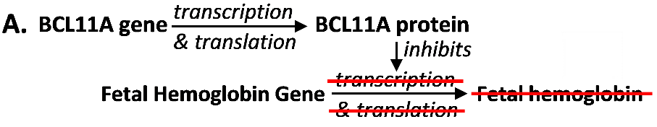

11a. Flowchart B shows what happens if developing red blood cells are treated with CRISPR-Cas9 that cuts the BCL11A gene, so the gene codes for a non-functional version of the BCL11A
protein. Explain how this CRISPR-Cas9 treatment could help patients with severe | 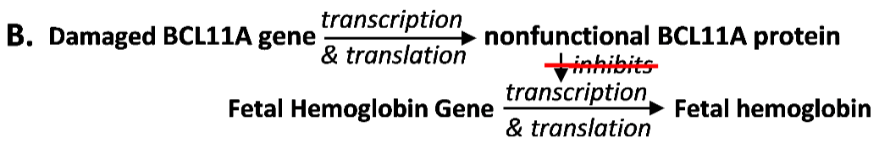
sickle cell anemia.

11b. Explain why this type of treatment is called gene editing.

To review and learn more about how CRISPR-Cas9 is being used in the treatment of severe sickle cell anemia, view the first 10 minutes (until “questions still to be answered”) of “How Gene Editing Is Curing Disease” (https://www.youtube.com/watch?v=ezfwqmKC9Uc,.

12. Explain why gene editing is only considered for patients with severe sickle cell anemia.

During the years since Victoria Gray received the CRISPR-Cas9 gene editing treatment, her health has improved dramatically. She has not had any painful sickle cell crises or any hospitalizations. She said “It’s hard to put into words the joy that I feel – being grateful for change this big. It’s been amazing.”

By Dr. Ingrid Waldron, Dept Biology, Univ Pennsylvania, © 2024. This Student Handout and Teacher Notes (with background information and instructional suggestions) are available at https://serendipstudio.org/exchange/bioactivities/GeneEdit.

